|  |  |  |
| --- | --- | --- |
| **The Islamic University of Gaza**  **Department of Computer science** |  | **Faculty of Information Technology**  **Second Semester 2022-2023** |

**Programming 3 Lab**

**Assignment 1 :**

* Write a javaFX program that implements an Currency Conversion System , the system should contain the following :
  + First apply the MVC Design Pattern on that System by Creating ( Model , View , Controller ) folders as we learned in lectures . ( 2 marks )
  + The System Contains two views you should make using SceneBuilder or Hand Written Code . ( 3 marks )
    - First view ( Login Page ) Like that

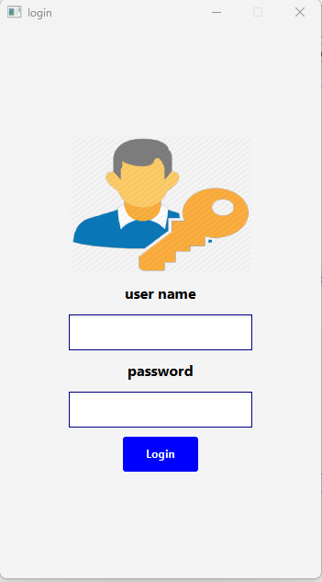

* + - Second view ( System Page ) Like that

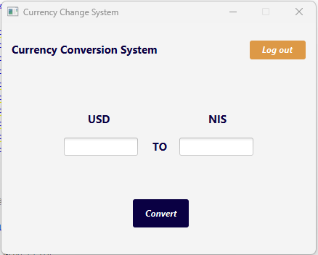

* + Make ViewManager class as we learned earlier to control the process of moving between stages ( Login Page and Currency Converstion Page ) . ( 2 marks )
  + Our System Functionality :- ( 3 marks )
    - When the program start should display our login page .
    - When User type ( user ) in user name TextField and ( userpass ) in password PasswordField the screen should change from login page to Currency Converstion Page , if user types another data in TextFields The system should show an alert to the user that this data is invalid .
    - Currency Converstion Page Functionality :-
      * The main function of this page is to convert the currency from dollars to shekels or vice versa .
      * when the user presses Convert Button the system should know what TextField typed and what is empty and make the convert function on the number from typed TextField and convert this number to the other currency number and show the new number in the empty TextField .
      * When the user presses Log out Button the The system should close Currency Converstion Page and show Login Page using ViewManager class .

Submission method:

Insert a text file containing the following:

1- Your name, university number, and department number

2- GitHub link for your completed project

طريقة التسليم :

قم بادراج ملف نصي يحتوي على التالي :-

1. اسمك ورقمك الجامعي ورقم الشعبة
2. رابط GitHub لمشروعك المنجز

Notes:

* This Assignment Should be Submitted Before at Thursday 20/ 4 / 2023 at 11:55 PM.
* اخر وقت لتسليم الاسايمنت هو يوم الخميس القادم بتاريخ 20/4/2023 الساعة 11:55 مساءاً
* To See the MVC and ViewManager implementation See our Lectures Project <https://github.com/yahyaashawish/JavaFX-Project> .
* Cheating in this Assignment, will make you get a big **Zero** Mark.